Dear (NAMI Office or person),

This packet of information is about an evidence-based practice in your state called Individual Placement and Support (IPS). An evidence-based practice is one that has been researched multiple times and found to be effective. The Individual Placement and Support (IPS) practice of supported employment helps people living with behavioral health conditions (mental illnesses and substance use disorders) work at regular jobs of their choosing. Although variations of supported employment exist, IPS refers to the evidence-based practice of supported employment.

Families may be active participants in helping individuals with employment, even when the person is receiving IPS services. Family members may join the IPS specialist and job seeker to talk about good job matches, they may meet with the job seeker and a benefits planner to learn how benefits would be affected by part or full-time employment, they may attend meetings to discuss school and career planning, or they may share their ideas about what job supports would be helpful.

In this packet you will find:
- A brief description of IPS services,
- A handout on what benefits planning is and where to obtain benefits planning,
- A handout describing how family members can be involved in IPS services,
- Testimonials from people with lived experience about employment, and
- Work is Recovery document.

IPS may not be available in every area. To learn about IPS where you live, contact:

Name:
Workplace:
Email:
Phone:
Name:
Workplace:
Email:
Phone:

What Is IPS?
Individual Placement and Support (IPS) is an evidence-based approach to help individuals who have serious mental illness and/or substance use disorders gain employment that they enjoy. In some situations, individuals are helped with school or training related to a career preference. IPS is based on the following eight core principles:

- Job Seeker Preferences -Preferences are important and the basis of all other principles. Preferences could be related to job types, duties, environment, hours/shifts, kinds of support desired, whether to disclose personal information at work, or ongoing support once a job is obtained.

- Zero Exclusion - People have access to IPS services in spite of possible barriers including legal problems, homelessness, substance use disorders, past problems with employment, mental health problems or other issues.

- Work Incentives Planning - All IPS participants are offered an opportunity to meet with a trained benefit planner to review how work income may impact their entitlements, to help them decide about working, and to determine how many hours they would like to work and how much they would like to earn.

- Integrated Employment & Treatment Services - IPS Specialists and mental health practitioners meet regularly to ensure collaboration in supporting a person’s treatment and employment goals.
- Rapid Job Search - Job seekers are not asked to complete pre-vocational groups or assessments before pursuing work. Most people begin their job searches within 30 days of beginning IPS services.

- Employer Relationship-Building- IPS Specialists make multiple in-person visits to employers to build relationships and learn about their businesses. This is done with a job seeker or on their behalf, depending on the job seeker’s preferences.

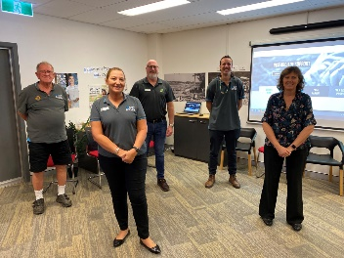
- Competitive Jobs - Regular jobs at regular wages are pursued. These are jobs that anyone can apply for, regardless of disability status.
- Time-unlimited Job Supports –
Different types of job supports are provided based upon each worker’s needs and preferences, and for as long as the person wants and needs them. Then natural supports, such as family members, friends, coworkers, and/or mental health practitioners, provide support for employment.

Education Supports
IPS Specialists provide supports for education and vocational training programs when they are related to a person’s career goal.

Employment and Benefits

This handout is a brief introduction to resources available to individuals who want to learn how their entitlements will be affected by part or full-time employment. Many individuals and their family members have concerns about how entitlements, like Social Security Disability Income or Medicaid, will be affected by employment. In general, almost everyone can benefit financially by working, but it is wise to obtain individualized information while considering employment. Certified Work Incentives Counselors (see below) are excellent resources for obtaining individualized information about benefits and employment.

More information about benefits planning is available at: https://choosework.ssa.gov/library/fact-sheet-benefits-counseling-and-the-path-to-employment.

Certified Work Incentives Counselors (CWICs): CWICs provide free, confidential services to individuals with disabilities who receive Supplemental Security Income (SSI) and/or Social Security Disability Income (SSDI). CWICs educate beneficiaries on how employment will affect their public benefits. CWICs are funded through the Social Security Administration grant--Work Incentives Planning and Assistance (WIPA). CWICs are not Social Security Administration employees. The best reason to consult with a CWIC may be their extensive and ongoing training on this complicated subject. CWICs provide individualized information and can offer “bottom line income” forecasting for different earning scenarios.

To find a CWIC near you: https://www.ssa.gov/work/WIPA.html, download WIPA Awardees midway down the page.

Another way some people access benefits planning with a CWIC is through Vocational Rehabilitation. Every state has offices of Vocational Rehabilitation (VR) to help individuals of all types of disabilities return to work. Clients of VR may also be eligible for a referral to a CWIC for benefits counseling. To find Vocational Rehabilitation in your state, go to: https://rsa.ed.gov/about/states. If the CWICs in your state charge a fee for benefits counseling, VR may be able to assist with that fee, as well as help an individual to obtain a job.

Terminology:
Entitlements or benefits: Examples are Supplemental Security Income (SSI), Social Security Disability Insurance (SSDI), Medicare, Medicaid, Veteran’s Benefits, food assistance (SNAP), housing benefits, etc.

Means-tested benefits: The amount provided to a beneficiary may be reduced as a person earns more money. Examples of means-tested benefits include SSI, food assistance, and many housing subsidies.

Able Accounts: Savings plans for individuals who were disabled before age 26 and receive means-tested benefits is at: https://www.ablenrc.org

Supplemental Security Income (SSI) and Social Security Disability Insurance (SSDI):

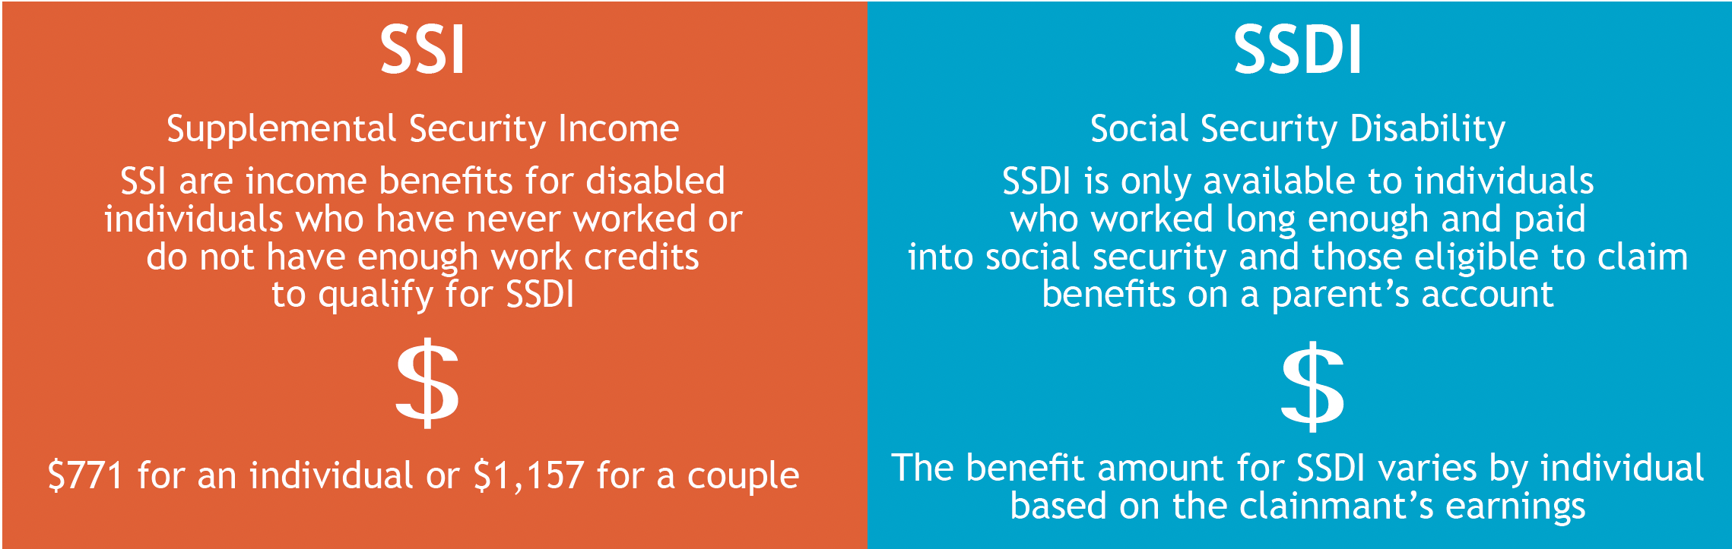

*These figures are current as of 2023

For those who receive Social Security Administration benefits such as SSI or SSDI or want to know the difference between them: https://www.ssa.gov/redbook/

State and local resources:

Disability Benefits 101 was developed by the World Institute on Disability. DB 101 provides tools and information on employment, health coverage and public benefits. People can use DB101 to plan ahead and learn how income from employment will impact their benefits. Some states have partnered with DB101 to develop detailed information for their own state including: Alaska, California, Colorado, Kentucky, Michigan, Minnesota, Missouri and Ohio. www.db101.org

How Family Members Can Be Involved in IPS Supported Employment

- Learn about how employment can be part of mental health treatment and how employment helps with recovery, stabilization, housing, physical health, improved self-esteem, and other important quality of life goals. Visit https://ipsworks.org/

- Teach others about IPS Supported Employment through Family-to-Family and word of mouth. Help NAMI with IPS booths at conferences and presentations about recovery through employment.

- Support local Supported Employment programs, for example, ask a local IPS Supervisor if a family member is needed for the IPS Steering Committee or in some other capacity.

- Contact local IPS Supported Employment program staff to learn how to be more involved and supportive of your loved one’s employment efforts.

- Mentor and support individuals and family members. Share information that you have (for example, information from this packet).

- Share contact information for community employers that you may know and share job openings you learn about.

- Advocate at the local, state, and national level for Supported Employment
  - Local & state legislative advocacy
  - Local mental health agency & state agency advocacy
  - Speak up in meetings about Supported Employment (ask questions, tell success stories, share ideas)

- Write about the importance of IPS Supported Employment in newsletters, emails, and other public forums. Share successes, information about new programs and IPS on social media.

For questions or ideas, please contact:

Employment Perspectives of People with Lived Experiences

My son worked in a factory for years. We didn’t realize that he had issues, but he quit his job because of his mental health problems. He tried to get disability benefits, but his application was turned down, so he started to look for another job. His IPS specialist provided him with inspiration, helped him follow up on job leads, and has been a great support person. My son loves his new job and only wishes he had more hours. He says he is finally doing something that benefits someone else. He has been working with teenagers who have physical and emotional difficulties for four years. He helps them find work and he supports them on the job by teaching them their job duties. And he encourages the young workers. For example, a manager told a young person that he had to finish his job in four minutes, but my son told the young person to just do his best.

I talked with my son’s IPS specialist now and then. He would ask what I think, and if I had concerns, I would say so. An example was that there was a job that was far away, and I worried about him traveling that far, but it all worked out.

I think work is good for my son. It gives him purpose. He has something to do, and he enjoys what he does.

I have been diagnosed by bipolar disorder and post-traumatic stress disorder. I’ve had trouble with alcohol and suicidal thoughts and attempts. One year I was in and out of the hospital 14 times!

A couple of years ago I came back to Oregon because this is where my family is. Since I’ve been here, I’ve been feeling better. I started to think that I needed to do something else besides sitting in my apartment. In September I saw an ad in the paper for a part-time dog groomer and I called them. They asked me to come in and try out grooming a couple of dogs. The owner liked my work and hired me on a part-time basis.

Now I’m working with Jeff (employment specialist) to get a Pass Plan from Social Security so that I can earn extra money while I start my own dog grooming businesses. We’re also working with a small business specialist from the local college to put together a business plan.

I feel more satisfied and fulfilled with my life. It takes my mind off my disability and gives me a chance to be with people. I enjoy working with customers and educating customers about their dogs.

Before Janice got her job at a catering company about one year ago, she hadn’t worked in 20 years. Now she has a job that she loves, “I tell my boss that I like working for him. I come in not because I have to, but because I want to.”

When Janice first began working, she had fears that the building would blow away. Her employment specialist worked with her supervisor and co-workers so that they would reassure Janice that she was safe. Her mental health team and group home providers also provided supports by making changes to her medications and helping with intrusive thoughts.

Now Janice is a valued employee. Her co-workers asked her to stay and have lunch with them after she finished her shift, but Janice declined the offer saying that she ought to get home. So, her co-workers tried moving their lunchtime back to noon, and eventually to 11:00AM so that lunch would occur in the middle of Janice’s work shift. Now Janice eats with them each day she works. “I love working with them. They hustle around and do their thing. I want to work. I want to feel handy and wanted and needed. So, I guess I’ll keep on trucking!

If it hadn’t been for everyone who helped my son since he was released from jail, he wouldn’t be the person he is today. Before he became employed, he sat around the house moping. Mental health treatment has helped him and having a job has been tremendous. Working a job is all my son talked about. Employment has given him independence, and he feels successful because he has a job.
In the beginning, his IPS specialist drove him to job interviews because he didn’t have a car. The factory that hired him was willing to work with his schedule for meeting doctors and nurses. When he got the job, his grandmother helped him get a car and he paid her back when he was working.
After the company shut down, he got laid off, but he went out and got a job on his own because he was feeling more confident. He is mechanically inclined and has been all his life. His current job is to build trailers for hauling cars and tractors.
I attended some appointments with my son. It gave me insight into what people were offering to him. I could see that they really wanted him to be successful. I didn’t need to worry as much about whether he would be able to work because I could see that he had a team of people who were helping him.

Work is Recovery

- Increased self-esteem
“I feel like I have accomplished something pretty cool. I’m shocked – I am more the person I was meant to be.”

- Better control of psychiatric symptoms
“I have a new goal to be a dental assistant. I remember when my goal was just to get out of bed.”

- Reduced criminal justice involvement
“In the past, I was having trouble by not working. I think I was doing drugs because I had so much free time.”

- Increased self-sufficiency
“In the past, people might have used labels to describe me such as ‘homeless,’ ‘mentally ill,’ and ‘welfare mother.’ Now my titles are ‘financial administrator,’ ‘college student,’ and ‘working mom."

- Decreased dependence on others
“Working allows me to get things I need and want and not feel guilty.”

- Increased connection to community
“The thing about being unemployed is that I was isolating myself and not getting out in the world. The world picks me up.”
“Now that I am working, I have something to talk about when I see my family. And I can hold my head up because I am paying taxes. I’m part of society again.”

